**WriteUp**

**Project Agenda:** To create an online quiz portal with multiple REST APIs where users can browse different quizzes, attempt them, and find their scores and standings.

**Description:**

This project, which aims to create an online quiz application, is based on different REST APIs through which users can log in and take quizzes. After finishing the quiz, they can find their standing and scores based on their accurate responses.

There are two types of users on this quiz portal:

* Admin user
* Participants

**Project Features:**

* Includes a RESTful Web API to perform CRUD operations on Domain objects as per requirement using Spring Boot and MySQL/Oracle database.
* The admin user has a separate API to access the admin portal, which requires authentication with the admin username and password.
* The admin user can update the profile details and change the password after using the access token generated by login.
* The admin user can add questions using the **addQuestions** API.
* The admin user can create a quiz by entering **quizid** and selecting questions with **questionid**.
* The admin user can obtain statistics on total quizzes, questions, and users by using their APIs.
* The admin user can find the users who participated in the quiz along with scores and standings.
* Users can explore various quizzes created by the admin.
* Users can create their profile using new user registration.
* Users can take the quiz and try to answer the questions.
* Users can also check if the given answers are correct, as well as their results and positions.

**Tools Required:**

* Postman
* Tomcat server
* MySQL

**Admin User Scenario:**

* The admin wants to create an online quiz for the website users.
* The admin creates a set of questions along with their answers.
* Admin opens login API and logs in with the admin username and password.
* Once admin is authenticated, an access token is generated that can be used to add and modify quizzes, questions, and users.
* The admin creates a quiz by providing a name and an id.
* For creating a new quiz, the admin user enters a **quizid** and selects questions from the database using the **questionid**.
* After adding the questions, the admin runs the API and makes the quiz available to its users.
* Once the quiz is released, website users can start taking it.

**Participants** **Scenario:**

* The user uses the register API to create an account, which provides an access token.
* After registering an account, the user logs in with the access token to take any quiz.
* The user browses various quizzes created by Admin using the **getAllQuizzes** API.
* The user attempts the quiz using **quizid** and gives the possible answers.
* The user views whether the provided answers are right or wrong. The correct answer is highlighted differently so that they are easily identified.
* After completing the quiz, the user checks the scores and compares their standings with other users.

**Sprint Planning**

**Sprint 1:**

4

3

1

**2**

**Sprint 2:**

4

3

2

1

**Sprint 3:**

* Pushing the code to the GitHub Repository.
* Creating Documents like flow of the Project, source code and output screenshots.
* Final check and completion of the project.

**FlowChart**

**Admin >> LogIn >> Update Info>>Create Question>>Create Quiz with selected by questionId>> View Participant Performance.**

**User>> Registration >> Login>> View All Quiz> Take Quiz**

**Project Structure**

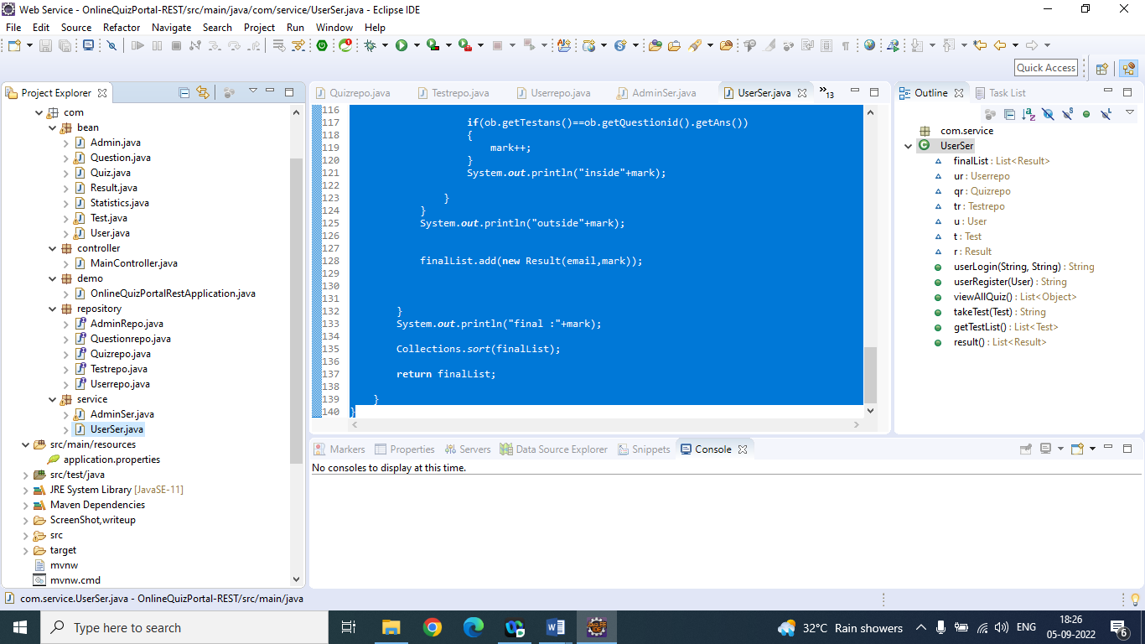

**Steps….**

1. **Create Spring boot project with dependencies: spring web, mysql driver, devtool, data jpa and update.**
2. **Create all entities in beans package which will create table in database.**
3. **Create all interfaces extend with JPA in repository package.**
4. **Create all service class with method in service package.**
5. **Create MainControlller in controller package to allow the operation on QuizPortal**
6. **Run as Spring Boot Application.**
7. **Teat the project with port number in Postman.**